Varndean College

Introduction to Word 2010



Introduction to The Computer

Hardware can be:

- a keyboard
- a monitor
- a base or system unit
- a mouse
- a floppy drive
- a CD-ROM drive
- a scanner
- a printer
- a sound system with speakers.

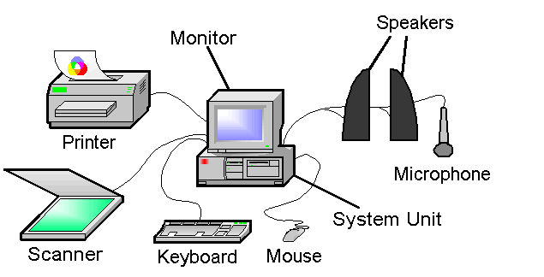
Floppy drive

CD-ROM Drive

Software makes the computer work (system software) and runs the programs used on the computer (application software).

Software contains the instructions and information (data) needed to tell the computer what to do.

Using a Computer Safely

The screen should not flicker. Light from windows and room lights should not be seen in the screen.

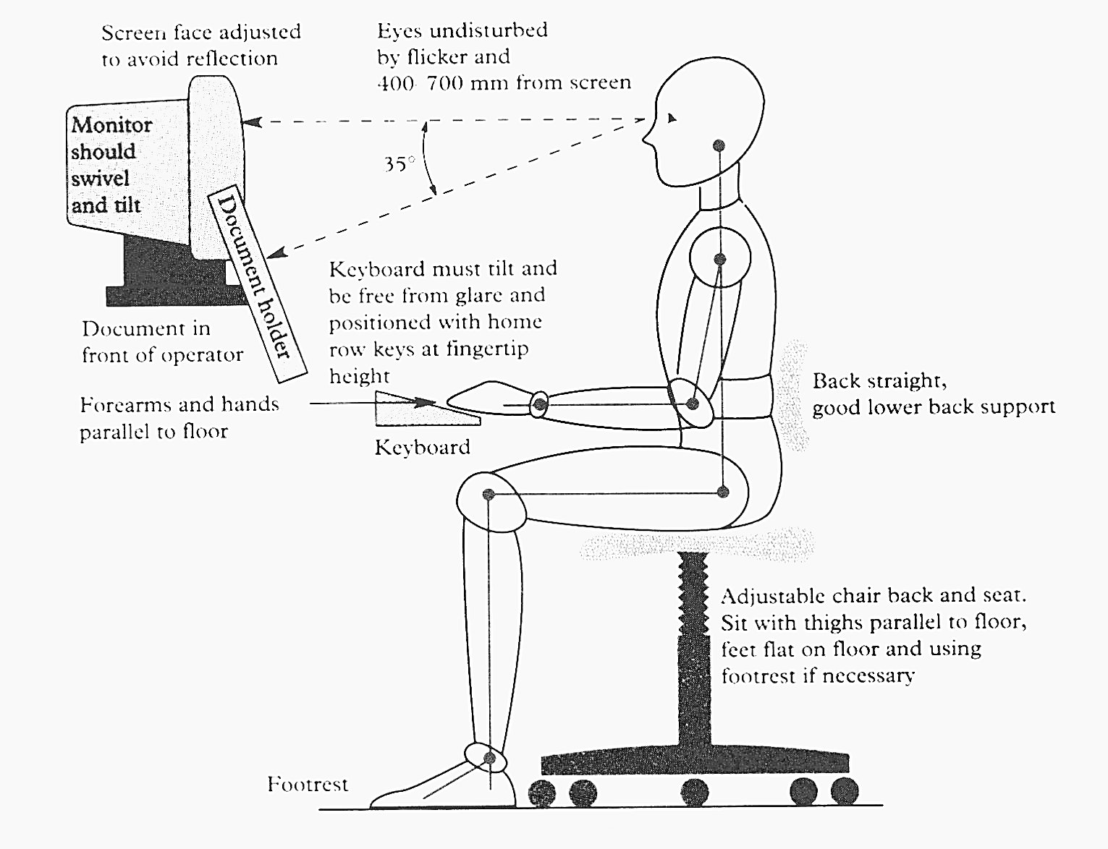
Back straight with support for lower back.
Eyes should be between 40 cm and 70 cm from screen.
Document in holder.

Must be able to change angle of the keyboard.

Screen should tilt and swivel.
Feet flat on floor. Use a footrest if feet do not reach the floor.
Must be able to higher or lower the chair and be able to move the back of the chair forwards or backwards.
Thighs parallel with the floor.
Feet flat on floor. Use a footrest if feet do not reach the floor.
Must be able to higher or lower the chair and be able to move the back of the chair forwards or backwards.
Thighs parallel with the floor.

Keyboard

Lower arms and hands in a straight line.

LOGGING ON

To use the computer you need to log on. Your tutor will give you:


- a username
- a password

- Switch on the computer and monitor (your tutor will show you how)

Wait for your computer to load. You will be asked to do the following:

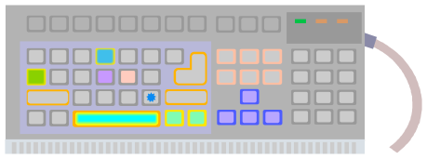
- Look at the keyboard

- Use both hands and hold down the three keys below:

Alt
Ctrl
Delete

The login box will appear

- Click the mouse once in the login box and type in your user name

- Press the Tab key on the keyboard or click the mouse
in the next cell and type in your password
Tab

- Click OK

LOGGING OFF

It is important to always log off correctly and shut down the machine when you have finished working. This is so that no one else can access your user area and so that all data is saved and programs are closed correctly.

You MUST log off BEFORE you switch off your computer.

- Click on the Start button 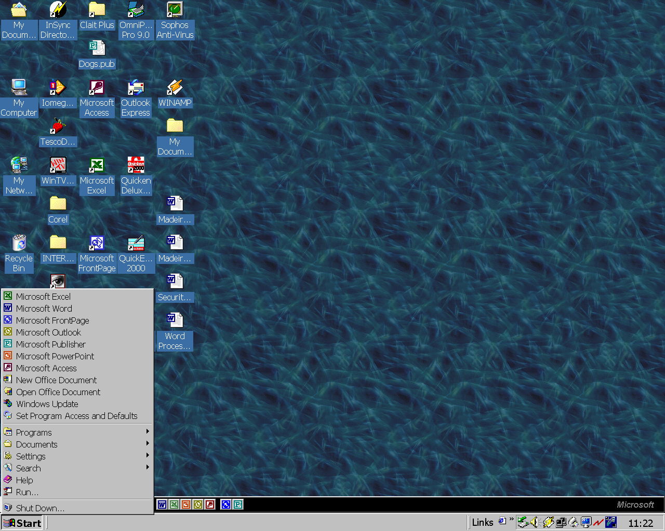

- Click on Shut Down

Ask your tutor how to log off your computer but generally:

If you want to switch off the computer:

- Click on Shut Down

- Click on OK

If you want to leave the computer on but log off of your area of the computer:

- Click on Log off

- Click on OK

The Desktop

When you have logged on you will see the desktop. This is your work area. You can customise it to fit your needs.

Below is a typical Windows desktop – your desktop may not look exactly the same.
Icons
Double click left mouse button (click 2 times) on one of these icons, or shortcuts, to open a program or folder

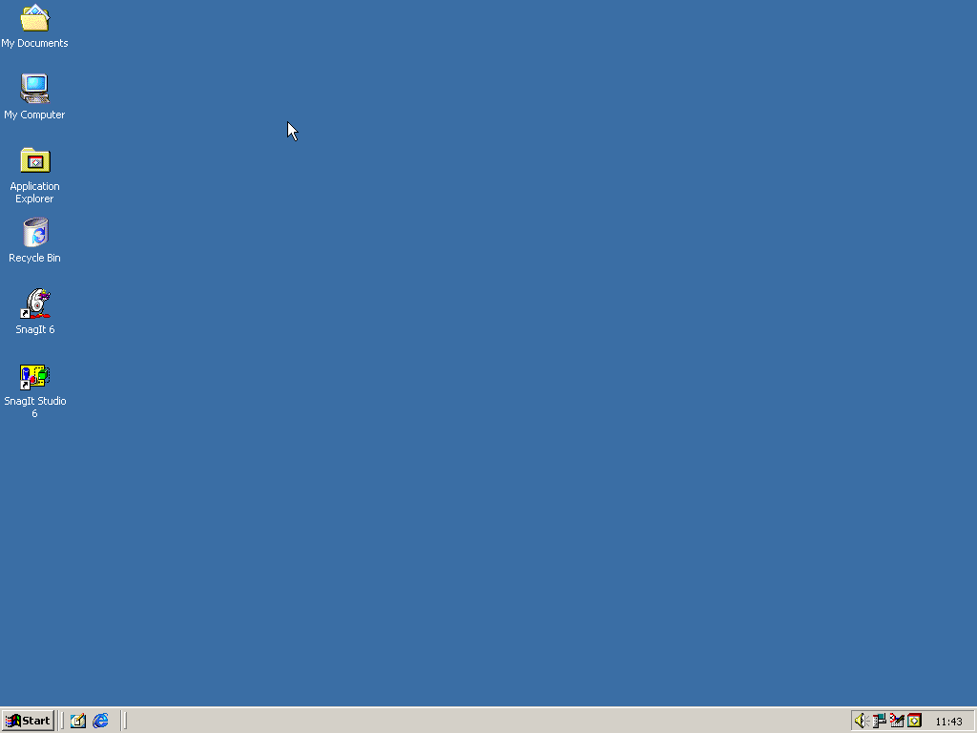
Quick Launch toolbar
Click on icons to start programs.
Taskbar
Shows windows that are open. Switch between open windows by clicking on the icons.
Time Clock
Shows the current time set in the computer.
Start button

Left click or right click to show the start menu.

Using The Mouse

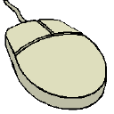
A mouse can have 2 buttons.

Or three buttons.

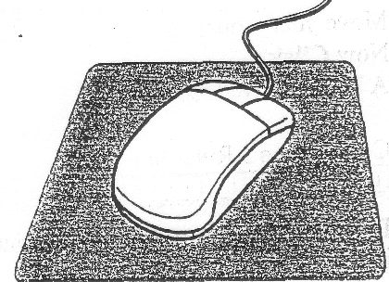

You can left click or right click
Some have a wheel in the centre for moving quickly through your document.

Single click - click once

OR

double click - click twice

Your first finger should rest on the left mouse button and
your middle finger on the right mouse button.

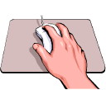

Place your thumb on the left side of the mouse and
your last 2 fingers on the right
(or the opposite way if you are left handed).

Try not to move your hand when you double click. Keep your wrist resting firmly on the mouse mat and move your hand around without raising your wrist.

In this workbook, click means click once with the left mouse button.

Word 2010 screen

When you start a computer program or open a document or a browser it appears on your desktop inside a window. Most windows have similar features – such as those to close the window or make the window larger or smaller.

An example of a typical window is:-

Title bar
Changes colour when the window is active
Close button
Quit the program and close the window

Quick Access Toolbar

Lists and Galleries
Ribbon tabs
File tab
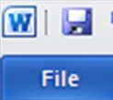
Ribbon
Vertical Scroll Bar
Zoom controls
View buttons
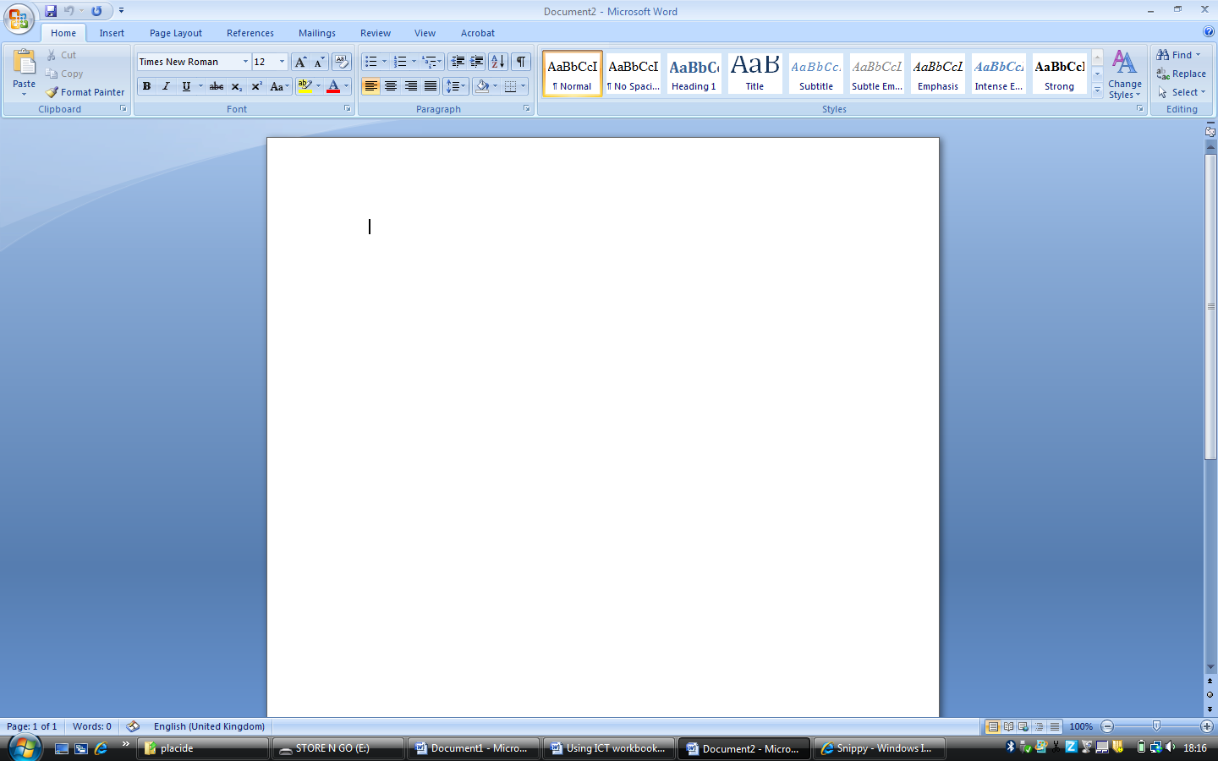
Status bar
Displays information about the active document
Horizontal
Scroll box
Corner
Resize the window by dragging from the corner
.
Horizontal Scroll bar

Moving, Sizing and Organising Windows

To Move a Window

Use the Title Bar to move a window around the desktop. Click on the title bar and hold the mouse button down. Move or Drag the window to a new location on the desktop. Release the mouse button to reposition the window.

To Resize a Window

Drag the windows edges or corners to make the window smaller or larger. Move the pointer over the edge of the window. The pointer will change to a double headed arrow – a resize pointer. Click and hold down the left mouse button and drag the windows edge in or out to make the window smaller or larger.

To Maximize & Minimize a Window

To make the window fit the entire screen or desktop
click on the Maximize button.

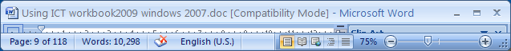

To restore the button down to the smaller size
click on the Restore Down button.

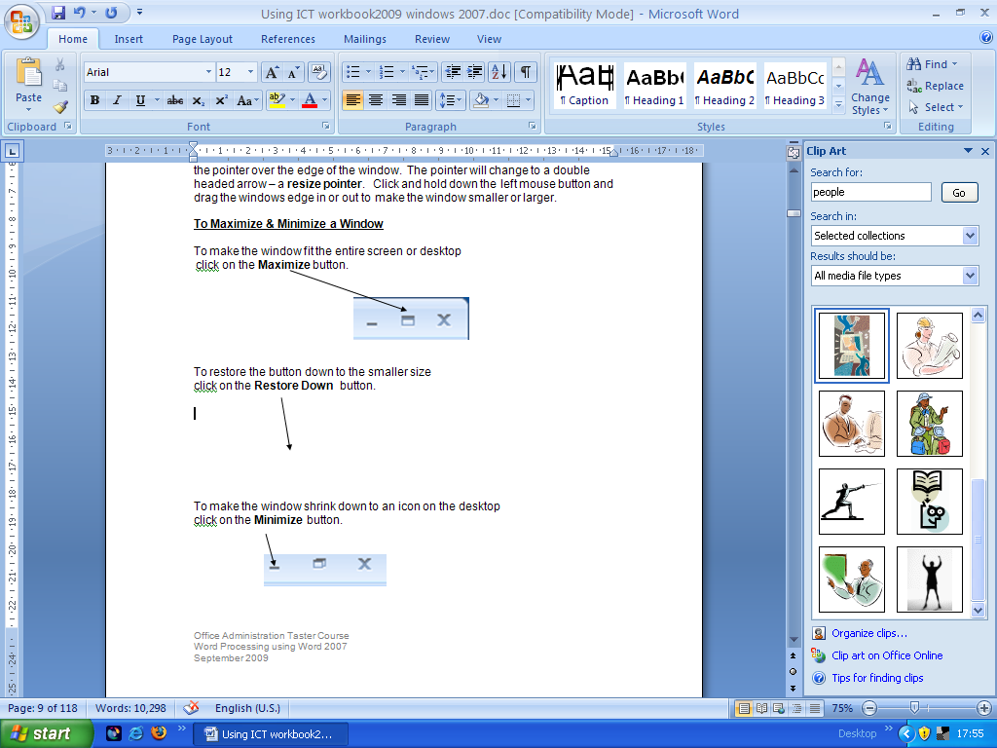

To make the window shrink down to an icon on the desktop
click on the Minimize button.

To close the window and close the application down altogether
click on the Close button.

Entering and Editing Text – basic keyboard functions

The Keyboard

Your keyboard may be different in some ways from this picture.
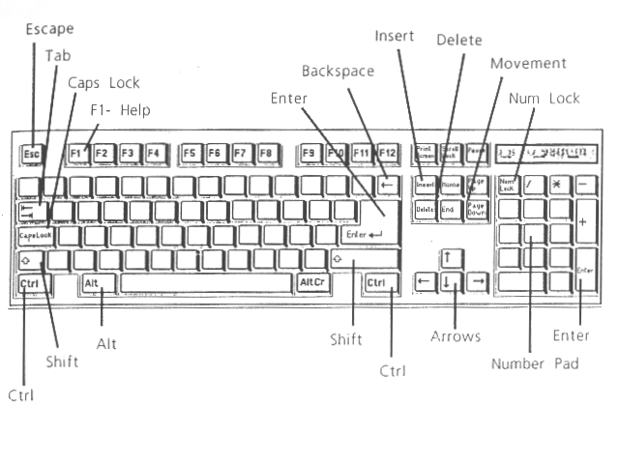
Space Bar

Escape Key  Press this to cancel what you have just done.  Esc | Arrow Keys  Use to move the cursor around the screen: left, right, up or down.
Backspace Key  Click after a mistake and press the backspace key.  Backspace | Delete Key  Click before the mistake and press the delete key  Delete

Home Keys

Look at the keyboard and find the keys A S D F

- Place your left, first finger on the F and place your other fingers on A S D

Look at the keyboard and find the keys J K L ;

- Place your right, first finger on the J and place your other fingers on K L ;

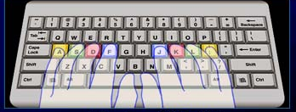

The four fingers of your left hand on the home keys A S D F

The four fingers of your right hand on the home keys J K L ;

Keep your fingers on the ‘home keys’ most of the time; only take them off to press another key.

Most of the time, the fingers move within three rows: the home row, the row above it and the row below it.

Two of the ‘home keys’ (F and J) should have raised plastic ridges on them. Your first fingers feel these ridges and this tells you your hands are on the ‘home keys’, even without looking.

Entering text

The insertion point or cursor is a blinking black vertical line. When you type your text will appear at the position of the cursor. When you have finished typing you can move the cursor anywhere within the text using either the mouse or the Arrow keys. To move the cursor with the mouse move the mouse pointer and then click to reposition the flashing cursor.

When you type in text, Word will automatically move onto a new line when the end of the line is reached – this is called wordwrap.

To Type Capital Letters

- To type a row of capital letters, press the CAPS LOCK key. Type the text and press the CAPS LOCK key again to turn the function off.
- To type single capital letters hold down one of the SHIFT keys as you type the letter.

To Type Symbols

- To type any symbol that appears on the top row of the keys (eg ! or “ or @) hold down the SHIFT key as you press the key.

To create a blank line

Press the enter key to move the cursor down a line. Press it again and the cursor will move down another line.

To Insert Text

Position the cursor where you want the text to go and type. The text will move along to accommodate the extra characters.

To select or highlight text

- Click and hold the left the mouse button down at the start of the text you want to highlight.
- Drag the mouse across and down the text.
- Release the mouse button when you reach the end of the block of text you want to select.

To Delete Text

- To delete characters to the left of the cursor – press the BACKSPACE key.
- To delete characters to the right of the cursor – press the DELETE key
- To delete a section of text – highlight the text and press the DELETE key.

Formatting text

Changing the format or the look and layout of the text can make it appear more eye catching and easier to read. You can change the layout and look of the text before or after you type it.

Changing Font and Font Size

A font is a set of characters of a particular design. The design gives the characters a specific style. Examples of different fonts are Times New Roman, Arial, Comic Sans MS, Century Schoolbook,
Old English Text.

Fonts can be either Serif such as Times New Roman or Sans Serif such as Arial. Serif fonts have ‘feet’ at the bottom of the letters and “shoulders” at the top.
Sans serif do not have feet at the bottom of the letters.

Most fonts can print out in different sizes. Word measures print size in “points” which is the height of the tallest letter in the font character set. 72 points is equal to 1 inch (2.5cm) vertically.

Make sure the Home tab is selected.
To change the font click on the down arrow next to the Font box.

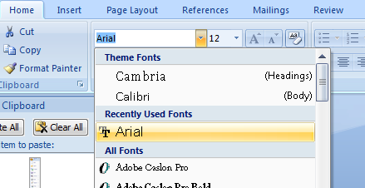

Use the up and down arrows on the scroll bar to see all the available fonts.

Click on the font you want to use.

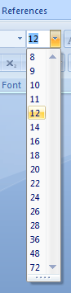
To change the font size click on the down arrow next to the Font size box.
Use the up and down arrows on the scroll bar to see all the available point sizes.
Click on the size you want to use or type any number

Changing Emphasis by Applying Bold, Italic and Underline

You can change the emphasis of text by using BOLD, ITALIC or UNDERLINE.

Note that the buttons will look orange when the function is ON.

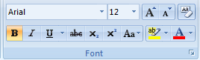
For Underlined text click on the Underline button

For Italic text click on the Italic button
For Bold text Click on the Bold button

These button work like switches. Click once to turn the function ON then click again to turn the function OFF.

If you are applying the emphasis to text that you have already typed. Select the text first then click on the appropriate button.

Alignment of Text

Alignment refers to the alignment of the left and right margins or edges. These may be straight (justified) or uneven (unjustified).

Text can be aligned to the left edge or to the right edge. It can also be centered so that the text appears exactly in the centre between the left and right margins, or justified so that the both the edges of the text are straight.

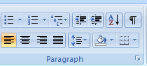

Click for justified text
Click for left aligned text

Click for centered text

Click for right aligned text

There are quick keyboard shortcuts for these setting, with the text selected:

Left Ctrl + L
Centre Ctrl + E
Right Ctrl + R
Justify Ctrl + J

Inserting and Manipulating Images in a Document

You can enhance your work further by adding an image or graphic to illustrate your poster.

Word has a gallery of images (Clip Art) that you can use in your work. Alternatively you can import a picture or scanned photograph from a file.

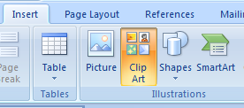
Inserting an Image from Clip Art

On the Insert tab click Clip Art.

The Insert Clip Art task pane will appear on the right side of the screen.
Click on the search text box and type a keyword in eg animals.

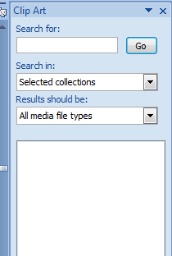

Click on the
Go button.

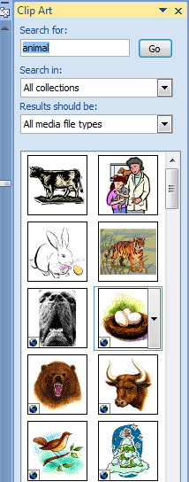

Small thumbnail pictures will appear in the task pane.
To insert a picture into your document, click on the picture you want.

The picture will be placed in your document at the position of the flashing cursor.

Or

Click on the centre of an image and drag it onto your document


To delete an image

Click on the image and then press Delete on the keyboard.

To make an image smaller/larger
Then click one of the black handles (square boxes) around the edge of the image.

Hold down the mouse button and drag the edge of the image either out or in.

Release the mouse button.
Click on the image.
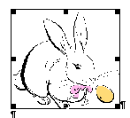

To move an image around a document

Click on the image and hold down the left mouse button.

Drag the image to where you want it to go.

Release the mouse button to re-position the image.

Text Wrap an Image

To move the image anywhere on the page and not disturb the text you must set the text wrapping controls.

Click on the image

From the Picture Tools tab which will appear, choose Wrap Text
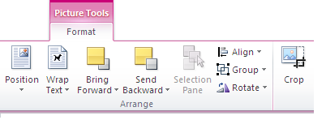

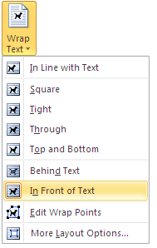

Choose the option
In Front of Text

You will now be able to move
the image anywhere on the page

Using Borders in a Document

You can use a border to frame the whole poster or just part of the text.

Page Borders

To add a border around the edge of the document…

On the Page Layout tab, click on Page Borders.

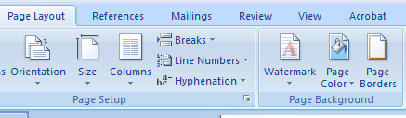

The Borders and Shading dialogue should appear.

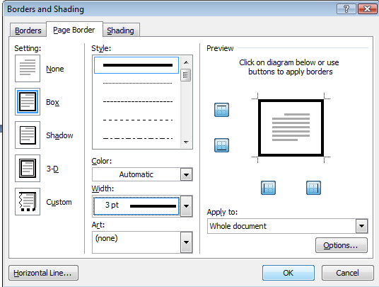

Click on the Page Border tab

Click on Box

You will see a line drawn around the edge of the text in the preview area on the right of the box

You can customise the appearance of the page border by changing the style, width and colour options.

- Click the down arrow next to the Style: box

- Select the style of line you want to use.

- Click on the down arrow next to the Colour: box
- Click on the colour you want to use.

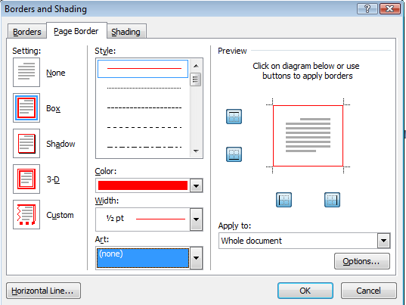
- Click on the down arrow next to the Width: box

- Select the width you want to use.

- When you have finished click OK

To ADD an ART BORDER to a page:
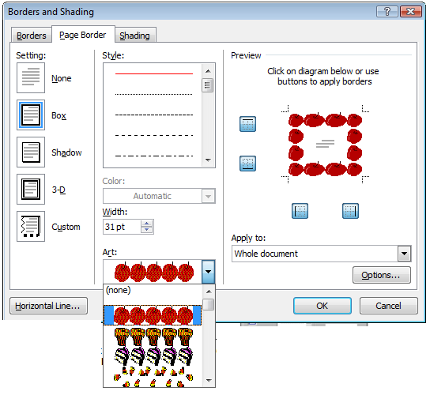
- Click on the down arrow next to the Art: box

- Click on a border you like

- When you have finished click OK

Borders around a Section of Text

To add a border around a section of text, highlight the section of text. Then ..

- Click on the Home tab
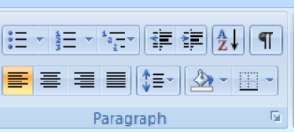
- Click on the arrow next to the outside border button
- Select a border from the list

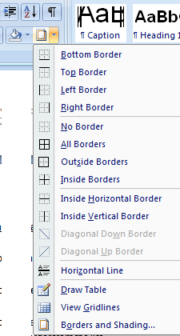

Or

- From the Home tab, click on the arrow next to the border button

- Click on Borders and Shading

Then ..

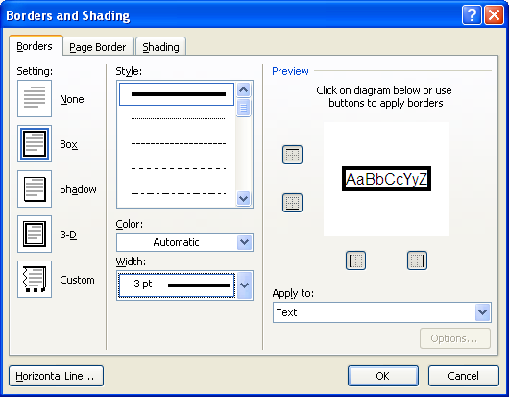
- Click on the Borders tab
- Click on Box
- Click on Style, Width and Colour
to change the appearance of the border
- Check Apply to: choose Text
- Click on OK when you have finished.

